FORM TO PARTICIPATE IN THE PUBLIC CONSULTATION
How to fill out and participate:
- Opinions, comments and proposals shall be submitted to the following electronic mail: mee@ift.org.mx. Maximum file size is 25 MB.
- Enter your full name (name and last name), company name or the legal representative’s full name (name and last name). In this last case, select the type of document to accredit such representation and submit as attachment a legible electronic copy to the same electronic mail address.
- Read carefully the PRIVACY POLICY to become aware of the care and safeguard of your personal data, as well as of the publicity to be given to the comments, opinions and contributions you submit as part of this consultation process.
- Enter your comments according to the structure indicated in Section II.
- In case you have general comments or any additional contribution, fill out the last box.
- In case you are interested, you may attach any documents you deem convenient to your electronic mail message.
- This public consultation will be held from December 3, 2018 to January 29, 2019 (i.e. 30 business days). Upon its conclusion, the submitted comments and attached documents will be available at: http://www.ift.org.mx/industria/consultas-publicas
- The following contacts are available to direct any questions, comments or concern about this consultation process to the Institute: Gerardo Martínez Cruz, Assistant Director of Spectrum Engineering, electronic mail: gerardo.martinezc@ift.org.mx or Roberto Carlos Castro Jaramillo, Director of Engineering and Technology, electronic mail: roberto.castro@ift.org.mx, with phone number (55) 50154000 ext. 4577 and 4740, respectively.
I. Respondent’s Information
Name or company name:
Legal representative’s name, if applicable:
Document to accredit representation:
In the case of a legal representative, attach a digital copy of the document to accredit such representation to the email message.
PRIVACY POLICY
In compliance with articles 3, section II, 16, 17, 18, 21, 25, 26, 27 and 28 of the General Law on the Protection of Personal Data Held by Private Parties (hereinafter, the “LGPDPPSO”) and numbers 9, section II, 11, section II, 15 and 26 to 45 of the General Guidelines for the Protection of Personal Data Held by Private Parties (hereinafter, the “Guidelines”), the Integrated Privacy Policy is made available to the users:

- Controller’s name: Federal Telecommunications Institute (hereinafter, the “IFT”).

- Controller’s address: Av. Insurgentes Sur, No. 1143, Col. Noche Buena, Benito Juárez, zip code 03720, Mexico City, Mexico.

- Personal data to be handled and its purpose: All comments, opinions and contributions submitted during every public consultation will be fully disclosed in the electronic portal of the Institute in an associated manner with the data subject and, in this sense, they will be considered invariably public in terms of number Eighth of the Public Consultation and Regulatory Impact Analysis Guidelines. This, because the nature of public consultations is to promote social participation and to transparent the new regulations making process, as well as any other matter that the Governing Board of the IFT may consider generating a space for the exchange of information, opinions and viewpoints on any matter of interest that this independent constitutional agency submits to public scrutiny. In case that information different from name and opinion is detected in the documents submitted, and it includes confidential personal data, it will be protected. Relating to the name and opinion of the respondent in this exercise, it is understood that consent is granted to disclose such information in at least the Institute’s portal, in terms of articles 20 and 21, second and third paragraphs, of the LGPDPPSO and numbers 12 and 15 of the Guidelines.

- Information relating personal data transfers requiring consent: Personal data collected for public consultation purposes will not be subject to transfers requiring the data subject’s consent.

- Legal basis granting authority to perform the treatment: the IFT, convinced of the usefulness and importance of transparency and civil participation in the new regulations making process, as well as any other matter of interest, performs public consultations based on articles 15 sections XL and XLI, 51 of the Federal Telecommunications and Broadcasting Law, last amendment published in the Federal Official Gazette on June 15, 2018, 12, section XXII, second and third paragraphs, and 138 of the Federal Economic Competition Law, last amendment published in the Federal Official Gazette on January 27, 2017, as well as Guideline Eighth of the Public Consultation and Regulatory Impact Analysis Guidelines of the Federal Telecommunications Institute, published in the Federal Official Gazette on November 8, 2017.

- Mechanisms and means available to the data subject to manifest his denial to the treatment of his personal data for purposes and transfers requiring the data subject’s consent: In accordance with section IV of this Privacy Policy, personal data collected for public consultation purposes will not be subject to transfers requiring the data subject’s consent. However, the following contacts are made available: Gerardo Martínez Cruz, Assistant Director of Spectrum Engineering and Roberto C. Castro Jaramillo, Director of Engineering and Technology, electronic mail: gerardo.martinezc@ift.org.mx and roberto.castro@ift.org.mx, and phone number (55) 50154000 ext. 4577 and 4740, with whom the personal data subject may communicate for any comment or question on this matter.

- The available mechanisms, means and procedures to exercise access, rectification, cancellation or opposition rights on his personal data treatment (hereinafter, the “ARCO rights”): Requests to exercise ARCO rights shall be submitted before the Transparency Unit of the IFT, by free form document, formats, electronic means or any other means established by the National Institute of Transparency, Access to Information and Personal Data Protection (hereinafter the "INAI”). The procedure will be governed by articles 48 to 56 of the LGPDPPSO as well as numbers 73 to 107 of the Guidelines, in accordance with:

- The requisites that shall be included in the request to exercise ARCO rights:

- Data subject’s name and address, or any other means for service;
- Documents to accredit the identity of the data subject or, when applicable, the capacity and identity of his representative;
- If possible, the area concerned with personal data treatment and before which the request is submitted;
- A clear and precise description of the personal data on which the exercise of any of the ARCO rights is intended;
- Description of the ARCO right to be exercised or whatever the data subject is requesting, and
- Any other element or document that may be useful to locate the personal data.

- The means by which the data subject may submit requests to exercise ARCO rights.

Same as established in paragraph eighth of article 52 of the LGPDPPSO, which indicates the following:

Requests to exercise ARCO rights shall be submitted before the Transparency Unit of the controller deemed competent by the data subject, by free form document, formats, electronic means or any other means established by the INAI for such purposes.

- Forms, systems and other simplified means that the Institute may have established for the data subject to exercise his ARCO rights.

The forms developed by the INAI to exercise ARCO rights are available at its Internet portal (www.inai.org.mx), in the “Protección de Datos Personales”/“¿Cómo ejercer el derecho a la protección de datos personales?/“Formatos”/”Sector Público” section.

- The means enabled to respond request to exercise ARCO rights.

In accordance with number 90 of the Guidelines, the response adopted by the controller may be notified to the data subject in its Transparency Unit or in the offices established for that purpose, prior accreditation of his identity and, when applicable, the identity and capacity of his representative, in person or through the National Transparency Platform or registered mail. Notice through a representative will not be valid when using these last means.

- The mode or means to reproduce personal data.

In accordance with number 92 of the Guidelines, the mode or means of personal data reproduction will be through direct consultation, in his location, or by simple copies, certified copies, magnetic, optical, sound, visual or holographic media, or any other technology determined by the data subject.

- The terms established in the procedure, which may not contravene articles 51, 52, 53 and 54 of the LGPDPPSO, are:

The controller shall establish simple procedures to allow the exercise of ARCO rights, with response times no exceeding twenty days from the day following reception of the request.

The term referred above may be extended one time only, for up to ten days, under justified circumstances, provided that the data subject is notified within the response term.

In case the exercise of ARCO rights is valid, the controller shall make it effective within a term that may not exceed fifteen days from the day following notice of response to the data subject.

In case the request for data protection does not comply with any of the requisites referred in paragraph fourth of article 52 of the LGPDPPSO, and the controller does not have sufficient elements to correct it, the data subject will be warned within five days following the submission of the request to exercise ARCO rights, for one single time, to correct the omissions within a term of ten days from the day following the notice.

Upon conclusion of said term without any response, the request to exercise ARCO rights will be deemed as not submitted.

The warning will have the effect of interrupting the term for the INAI to respond the request of exercise of ARCO rights.

In case the controller is not competent to process the request for exercise of ARCO rights, it shall notify the data subject on such situation within three days following submission of the request, and in case it may be determined, direct him to the competent controller.

In case provisions applicable to certain personal data treatment establish a specific procedure or process to request the exercise of ARCO rights, the controller shall notify the data subject on its existence within a term of five days following submission of the request to exercise ARCO rights, so that the latter may decide whether to exercise his rights through the specific procedure or by the process that the controller may have instituted to care for requests to exercise ARCO rights in accordance with articles 48 to 56 of the LGPDPPSO.

In the particular case, no specific process exists to request the exercise of ARCO rights relating to personal data collected for the consultation process at hand. (Case description, when applicable).

- The data subject's right to submit a writ of review before the INAI in case of disagreement with the response.

Such right is established in articles 103 and 116 of the LGPDPPSO, which indicate that the data subject, in his own behalf or through his representative, may file a writ of review before the INAI or the Transparency Unit of the controller who has heard of the request to exercise ARCO rights within a term of fifteen days from the day following the date of notice of the response.

- Address of the Transparency Unit of the Federal Telecommunications Institute: Av. Insurgentes Sur, No. 1143, Col. Noche Buena, Delegación Benito Juárez, zip code 03720, Mexico City, Mexico. Ground Floor, phone 50154000, ext 4267.

- The means by which the controller will communicate data subjects on changes to the privacy policy are: All changes to the Privacy Policy will be notified to the data subjects in the public consultation section of the IFT’s Website.

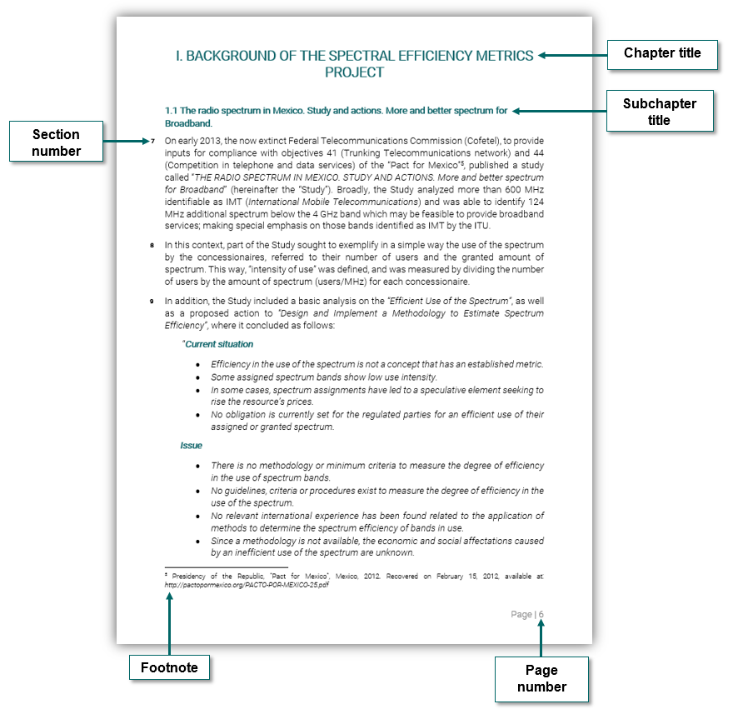
II. Guide to identify the section number in the study “Spectrum Efficiency Measurement. Definitions and considerations to be observed for its application in Mexico

III. Public Consultation for Integration Questionnaire
Note 1: The study “Spectrum Efficiency Measurement. Definitions and considerations to be observed for its application in Mexico” is a reference document (of imperative reading) to support the understanding of the questions listed below. The study itself is not subject to public consultation.
Note 2: Answering all the questions included in the following table is recommended, along with arguments and elements as you may deem necessary to support the opinion, including supporting documents that you may want to attach.
Question no. | No. of section in the Study | Question | Comment, opinion or contribution
1 | 5 | How to measure spectrum efficiency?
2 | 5 | Which parameters shall be considered in the metrics?
3 | 5 | How should the result of the metrics be parametrized?
4 | 82 | How should the Institute cause compliance with the SEIM among capacity providing concessionaires?
5 | 84 | What happens when different technologies with different spectrum efficiencies, not only by frequency bands but also by concessionaire, are present?
6 | 84 | A concessionaire uses, for example, two technologies to provide its service; should it have two different metrics?
7 | 86 | Should the SEIM observe or not the under-utilization of the spectrum for this type of services?
8 | 86 | Should public security and disaster relief concessionaires be evaluated?
9 | 88 | Would it be desirable that spectrum concession titles issued in the future establish a specific obligation on compliance with the minimum threshold of the spectrum efficiency metric?
10 | 89 | Would it be convenient to implement metrics for certain services where factors are based on the number of services offered by the concessionaire to the end user?
11 | 91 | How would this minimum number of services be determined?
12 | 91 | Would the established services be determined by frequency band or by geographic region?
13 | 91 | Would it be fair for all concessionaires to count the number of services provided to the end user as part of the metric?
14 | 93 | What kind of mechanism should the Institute implement to collect information from the concessionaires (through Guidelines, as an explicit obligation in concession titles, etc.)?
15 | 93 | How often and with what type of format would data collection be made?
16 | 97 | Who of the two concessionaires should observe the spectrum efficiency metric, the WMC, the MVNO or both?
17 | 97 | Should ad-hoc metrics exist for MVNOs?
18 | 97 | Should different metrics exist between WMCs and mobile telephone service concessionaires who are not WMC?
19 | 97 | Does a mobile telephone service concessionaire become spectrally more efficient when offering a wholesale service option, as compared with a MVNO?
20 | 98 | Would it be possible (or even feasible) that the weight of the metric be negotiated between the WMC and the MVNO, and established contractually (prior authorization by the Institute)?
21 | 100 | Is it possible to establish a spectrum efficiency metric for concessionaires that implement these types of technologies in the future?
22 | 100 | How may the metrics be established for this type of concessionaires under the spectrum lease mode?
23 | 100 | Since this type of technologies may cover an ample range of spectrum, transmit and receive information through free spectrum, and even transmit over granted bands under a no-interference schema; would it be possible to establish a metric that counts over which frequency band the transmission is being made, and the period of transmission?
24 | 100 | Being technologies that use the spectrum in a dynamic and shared manner; would they be not appropriate for evaluation?
25 | 101 | Coverage was defined by ABS for some trunking radio service concessionaires, by road routes for others, by cities for others and by municipalities for others. In case a factor of the metric was the geographic coverage area, would it be possible to measure all of them in the same fashion?
26 | 101 | Is it feasible to obtain a metric applicable to the whole universe of concessionaires for each one of the telecommunications and/or broadcasting services?
27 | 102 | Should specific metrics be designed for concessionaires different from those with commercial use?
28 | 104 | How should the quantity and quality of channels arising from the use of multiprogramming and IBOC technology be evaluated on the concessionaires?
29 | N/A | The Institute is evaluating the development of metrics for a group of services deemed of higher relevance or impact for the provision of public telecommunications and broadcasting services. The services considered up to now are:  - Wireless access service (cell phone).  - Point-to-point terrestrial fixed service.  - Satellite pay TV services.  - Mobile narrowband radiocommunication services.  - Digital Terrestrial Television services.  - AM and FM broadcasting services.  In this sense, the Institute seeks comments about additional or different services (besides the ones listed) that may be considered to develop and apply efficient use metrics, as well as the technical or regulatory justification on the feasibility and need for their implementation.

IV. General comments, opinions and contributions by the respondent
Note 3: This section may be used to freely offer comments, opinions and contributions related to the design and definition of Spectrum Efficiency Metrics. In case of making any contributions relating to the study “Spectrum Efficiency Measurement. Definitions and considerations to be observed for its application in Mexico”, indicate the corresponding section in the first column; otherwise, the indication “N/A” (Not Applicable).
Note 4: Add as many lines as necessary.
No. of section in the Study | Comment, opinion or contribution

